Rossburn Municipality

Request for Proposal
for
Removal and demolition from Municipal owned Property
located at
56 Cloverdale Ave
13 Pine St (Desc 8 663)
130 Victoria Ave E

Deadline: November 4, 2025

Introduction
Rossburn Municipality is seeking proposals for the removal of trailer and concrete pad from municipal owned property located as follows:
56 Cloverdale Ave
Trailer and concrete pad

13 Pine St
Trailer and attached building

130 Victoria E
House and attached garage

Proposal Requirements
Proposals should include the removal and disposal of building (s) on the lot, removal of all construction debris (included but not limited to wood, metals, bricks, concrete, glass, etc.) and related garbage from the site. Disposal of building materials is to occur in accordance with local regulations. In addition, back filling the area once concrete has been removed with base material.
The Municipality reserves the right to seek clarification with the Bidder(s) to assist in evaluations.
The highest bid or any bid will not necessarily be accepted.
The Municipality reserves the right to withdraw any or all tenders or any portion thereof.
The Municipality is not required to accept a bid if the Municipal Council decides not to proceed with the sale.

Evaluation Criteria
Request for Proposal forms, addendums and other information may be obtained at the office of the Rossburn Municipality, Rossburn, MB.

Terms and Conditions
All bid documents, including those requiring completion, shall be filled in and returned intact.
Building Condition and Disclosure
- Trailers and or house/garage to be removed are in "As-is" condition the contractor accepts the building in its current condition, including any known defects or environmental concerns.
- Contractor accepts responsibility for inspections and due diligence.
- The contractor accepts all contents of the building and will arrange for their removal following Municipal guidelines for the disposal of waste items. Ie. Concrete and shingles must be removed to the Rossburn Municipal Gravel Pit.
Contractor Obligations
- Compliance with Municipal regulations.

Contact Information
Inquiries may be directed to Emily Sawchuk, Chief Administrative Officer, Rossburn Municipality by phone at 204-859-2779 ext. 103 or by email at cao@rossburn.ca
Proposals may be submitted as follows:
At the Rossburn Municipal Office:
43 Main St N
Rossburn MB, R0J 1V0
Re: Clean up of Municipal Owned Property

Or by email to:
Emily Sawchuk at cao@rossburn.ca
Subject line: Clean up of Municipal Owned Property
Proposals received after the deadline of November 4, 2025 will not be accepted.

Proposals will be presented in the open session of Council at the November 6, 2025, at the regular Council Meeting.

Contractor Information
CONTRACTOR INFORMATION
Please fill out the following form, naming one person to be the contractor’s contact for the RFP process and for any clarifications or communication that might be necessary.
Full Legal Name of Applicant:
Any Other Relevant Name under which Applicant Carries on Business:
Street Address:
City, Province/State:
Postal Code:
Phone Number:
Fax Number:
Email:

Contractor Name

Authorized Signature Date:

Bid Information

LOCATION | TO BE REMOVED/ DEMOLISHED | AMOUNT ($)
56 Cloverdale Ave | Trailer and concrete pad
13 Pine St | Trailer/ attached building
138 Victoria E | House and attached Garage

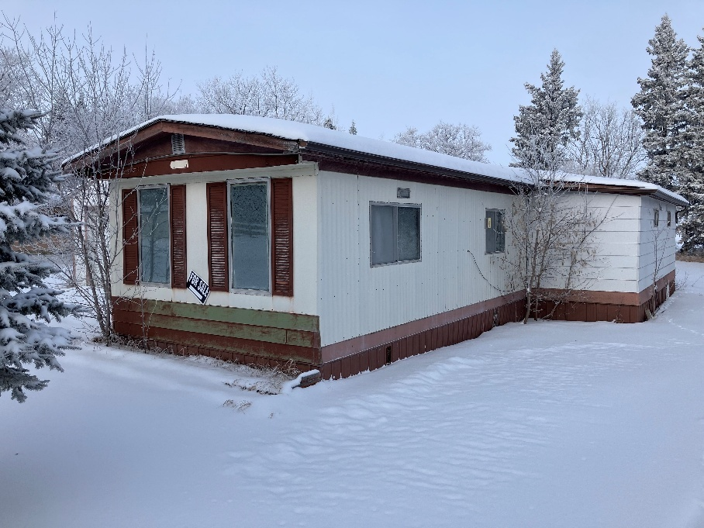
56 Cloverdale Ave

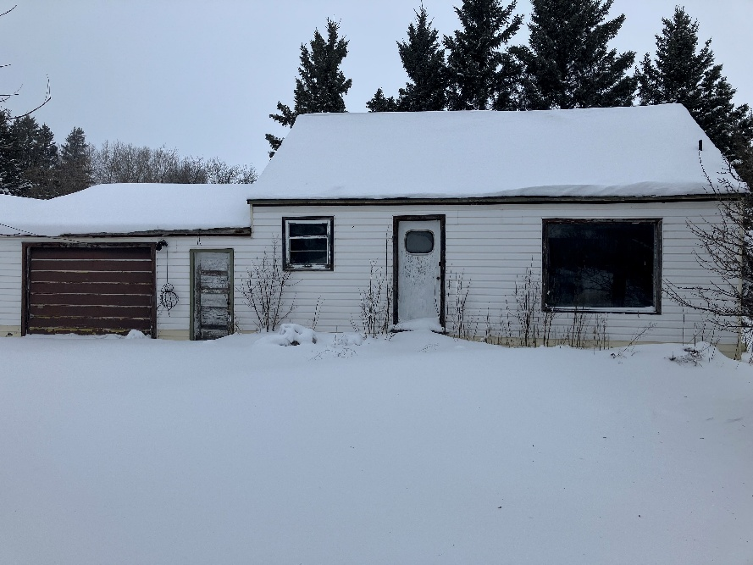
138 Victoria Ave E
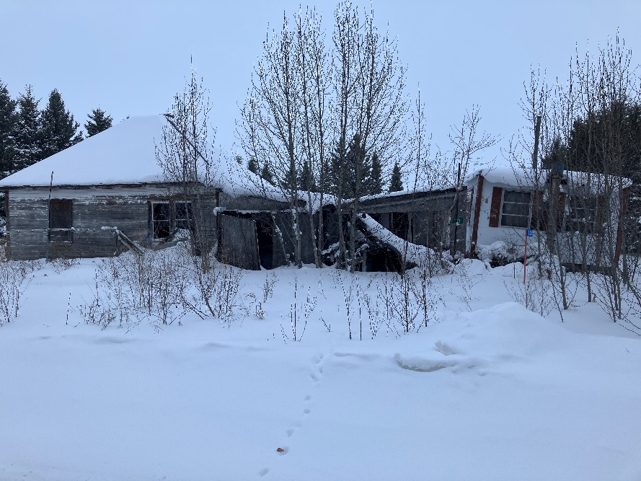
13 Pine St

